THE NATIONAL COUNCIL OF WOMEN
of South Australia Inc. presents
THE RUTH GIBSON MEMORIAL AWARD

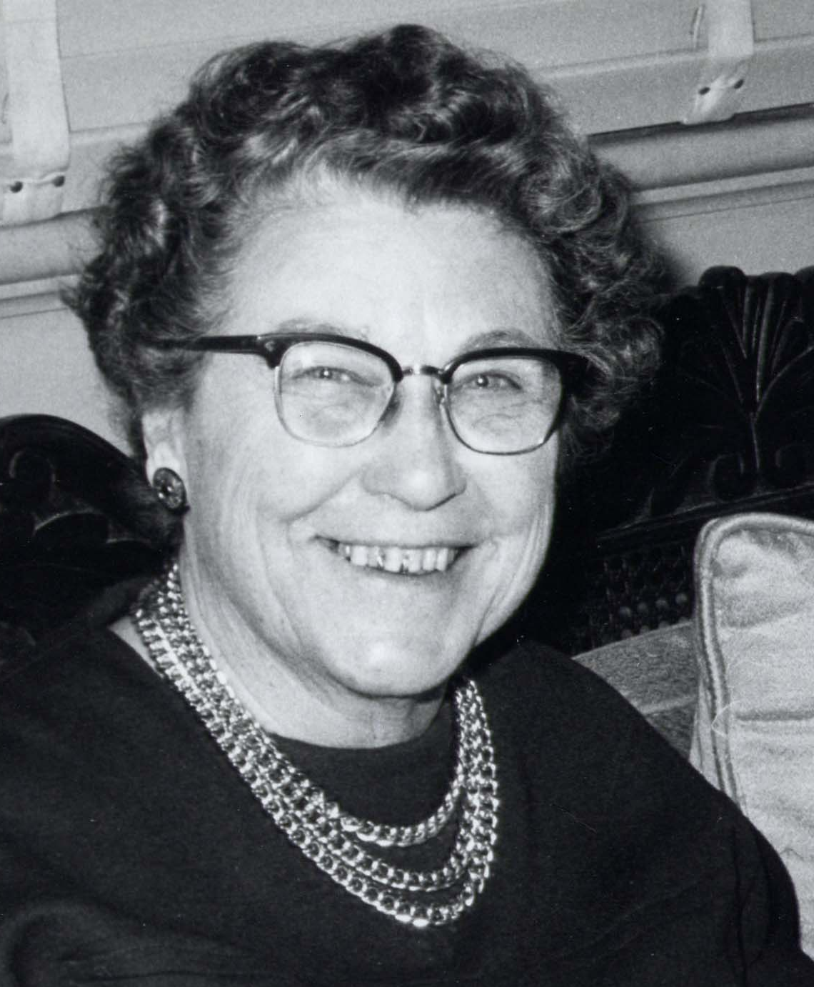

GLADYS RUTH GIBSON CBE
BA, DipEd, FACE

29 DECEMBER 1901 − 23 AUGUST 1972
THE RUTH GIBSON MEMORIAL AWARD

This award(s), of up to A$4,000, will provide financial assistance for a woman to further the applicant’s studies and/or research, or to travel to a meeting, seminar, symposium or conference, either in Australia or overseas for purposes approved by the Ruth Gibson Memorial Award Selection Committee. It is expected that the projects will benefit women and girls in the South Australian community. Refer to Selection Criteria and Conditions for more details.

Miss Ruth Gibson was a woman of tremendous vigour, keen interest, and strong friendship. She was no women’s suffragette, but was ever ready to put her tremendous energy and efficiency into any cause which she believed to be in the interests of women generally and to raise their status in the world.

Ruth Gibson was born in Adelaide and remained a staunch supporter of her home city, while, at the same time, exercising her love of travel whenever opportunity afforded. The main opportunities were provided through meetings of the National Council of Women at National and International levels.

Ruth Gibson joined the Education Department as a teacher in 1921. In 1941, her abilities were recognised in her appointment as Inspector of Schools, in succession to Miss Adelaide Miethke. This position took Ruth to all parts of South Australia where secondary school classes existed. In due course, her educational affiliations included the Adelaide Women Graduates’ Association (President), the Adelaide University Graduates’ Association (Vice President), the Australian College of Education SA Chapter (Treasurer), Florence Nightingale Committee for Nursing Scholarships and the Churchill Fellowship Selection Committee (SA).

In addition, Ruth Gibson was a foundation member of the Adelaide Soroptimist Club (later President), President of the Adelaide Young Women's Christian Association, member of the State Council Girl Guides’ Association, the Junior Red Cross Committee, the United Nations’ Association of SA (Vice President), the Australia Day Committee and the ABC Talks Committee.

While this list is not exhaustive, it does portray the diversity of interests of this remarkable woman. It was, however, the NCW which claimed her first love, and which indeed provided Ruth Gibson with her most valuable training ground for public office. She attended her first international gathering of NCW in 1938, and from that time her interest never flagged. She became President of the SA Council in 1951, President of the NCWA in 1952, and represented the Commonwealth of Australia at the Coronation of Her Majesty Queen Elizabeth II. She was awarded the OBE in the Coronation Honours List and the CBE in the Queen’s Birthday List of 1971.
Ruth Gibson attended most of the triennial conferences of the International Council of Women, held in various cities of Europe and the UK. She became a Vice-President of ICW and, when her term expired, was elevated to the Committee of honour. She was approached for nomination as President, but for a number of reasons, declined.

Ruth Gibson initiated the purchase of NCW House in Adelaide, later to become the property of the NCW War Memorial Fund. Over many years she worked hard with her fellow trustees for the freehold of this property.
Government assignments for Ruth included appointment to the Rent Control Enquiry in SA (1951), representation of the Australian Government at the United Nations Status of Women’s Commission Meetings in Geneva (1956) and New York (1957), when she acted as Rapporteur.

This catalogue of interests and activities must not obscure the personal involvement, the hearty humour and the humble service that Ruth Gibson added to her zest for life, nor must it overlook her life-long insistence on family claims above all others. She was devoted to her family and in later years of retirement, derived much pleasure from great-nieces and nephews, as she did from their parents. At the time of her death, Ruth was President of the Royal Flying Doctor Service of Australia, SA Section.

It is not surprising that when she died, the NCWSA felt that steps should be taken to set up a permanent memorial that would be worthy of Ruth Gibson’s lifetime of service, both to her own state and beyond.

A bronze sun-dial erected on the Plaza of the Adelaide Festival Theatre and a Scholarship Fund offered through NCWA and ICW, were made possible by gifts to a public fund organised by the President of NCWSA and opened by the Lady Mayoress of Adelaide. The sun-dial, executed by Owen Broughton, bears the inscription: In Memory of Gladys Ruth Gibson CBE, 1901−1972, Zealous Citizen, educator and worker for the advancement of women. Erected by her many friends.

The plaque was set in position in November 1973 and dedicated by the ICW President, Dr Mehrangiz Dolatshahi. The scholarship was first offered in 1978 and aims to perpetuate those ideals which Ruth Gibson pursued in the interests of women.

THE RUTH GIBSON MEMORIAL AWARD 2021

Conditions

- The applicant for the Award must not previously have won the award and must be:
  - an Australian citizen or have Australian permanent resident status or a resident of South Australia for three (3) years immediately before applying
  - a delegate or Individual Member of The National Council of Women of South Australia Inc. (NCWSA), or must be sponsored by a financial affiliated organisation of the National Council of Women of South Australia Inc.
NB: Applications for Associate Membership must be received, with payment, by the NCWSA Office prior to the close of applications.

- The applicant must be at least 18 years of age at the time of making the application.

- The project for which the application for the Award is made must be to further the applicant’s studies and/or research, or to travel to a meeting, seminar, symposium or conference, either in Australia or overseas for purposes approved by the Ruth Gibson Memorial Award Selection Committee. It is expected that the projects will benefit women and girls in the South Australian community. Refer to Selection Criteria for more details.

- The Award will be made only for forward projects.

- The applicant may be required to provide further information to, or be interviewed by, the Selection Committee.

- The Selection Committee reserves the right to fix the amount of the Award and/or to advise that more than one Award may be made. The total amount of the Award(s) in 2021 shall be up to A$4,000.

- Applications must be received no later than 5 pm on Tuesday 8th June 2021.

- Receipt of your application will be acknowledged by email shortly after the closing date.

- Applicants will be advised of the outcome no later than 28th July, 2021.

- Late applications will not be considered.

- All applications are confidential. The applicant shall accept the decision of the Selection Committee as final and shall not be entitled to any explanation or information from the Committee regarding her application.

- The award recipient(s) will be required to present an interim report within twelve months of receipt of the Award, and a written final report on completion of the project.

- Recipients of the Award(s) will be expected to present their findings to the National Council of Women SA at completion.

- The presentation of the Award to successful applicants will be held in the fourth quarter of 2021. Date to be advised.

PLEASE RETAIN A COPY OF YOUR COMPLETED APPLICATION FORMS FOR YOUR RECORDS.

*For more details, please contact the NCWSA Office on 8231 9154 or by email: RuthGibson@ncwsa.org.au

THE RUTH GIBSON MEMORIAL AWARD 2021

Application Form

Family Name: (With Preferred Title): ………………………………..…………………………………………………….…………..

Given Names: ……………………………………………..………………………………………………………………………….…..

Address: ……………………………………….………………………………………………….………………………………...………

…………………………………………………………………………………………….……… Postcode:………….….…………...

Contact Telephone: ………………………………………………………………………………………………….……………….

Email: …………………………………………………………………………………………………………………….……………………

PROJECT DETAILS

Project Title: ……………………………………………………………………………………………………………………………..

………………………………………………………………………………………………………….…………………………………………

Start Date of Project: ……………………………………………………………………………………………………..……………

Duration of Project: ……………………………………………………………………………………………………..……………...

Details of Project: please attach project description which must not exceed two typed A4 pages, 10-point font.

THE FOLLOWING HEADINGS ARE TO BE ADDRESSED:

- SUMMARY – a brief summary of the project or training
- PURPOSE & OBJECTIVE – The “Why” of the project/training
- BACKGROUND & SIGNIFICANCE – reasons and rationale for the training or project in relation to the benefits to women and girls in the South Australian community
- PROJECT DESIGN – What will you do, how will you do it and how will you review the outcomes
- OUTCOMES AND REPORTING – Explain the desired outcomes and include how you will report your findings
- TIMETABLE – Start and Finish dates
- BUDGET & JUSTIFICATION OF COSTS

DECLARATION:
“I, AS THE PRIMARY APPLICANT, DECLARE THE INFORMATION GIVEN IS TRUE AND CORRECT. I ACCEPT THAT THE APPLICATION MAY BE UNSUCCESSFUL AND RESPECT THE DECISION OF THE PANEL AS FINAL”.

I understand that there is a requirement for me to present to the National Council of Women of South Australia both an interim report within twelve months of receipt of the Award and a written report and presentation of findings on completion of my project.

I hereby give sole permission for National Council of Women of South Australia to use my name, photo and project title for future publicity and for the Ruth Gibson Memorial Award.

I confirm that I am 18 years or older at the time of application. YES / No

SIGNED………………………………………………………… DATED…………………………..……………………………

Referees: 1. Name: …………………………………………………………………………………………………

Address: ..................................................................................................

Contact Telephone: …………..…………………………………………………………………

Email: ………………………………………………………………………………………………….

2. Name: ………………………………………………………………………………..………………

Address: ..................................................................................................

Contact Telephone: …………..…………………………………………………………………

Email: ………………………………………………………………………………………………….

This completed form is to be received by
the Secretary
Ruth Gibson Memorial Award Management Committee
℅ The National Council of Women of SA Inc. 95 South Terrace ADELAIDE SA 5000

No later than 5 pm on Tuesday 8th June 2021, with the Application fee of $20.00 paid via Direct Electronic Deposit (NCWSA’s Banking Details: Bank SA BSB 105-139 Acc. No. 035526740). Please include your Name as reference and “Ruth Gibson”.

THE RUTH GIBSON MEMORIAL AWARD 2021

Instructions and Checklist for the Applicant

The Applicant is required to supply the following information via email to RuthGibson@ncwsa.org.au:

1. Name and address of the sponsoring organisation and details of your involvement with this organisation (if there is a sponsoring organisation). | □
2. Details in full of project for which the Award is sought, including a budget for the project. This is not to exceed two typed A4 pages in at least 10 point font. | □
NB: It is expected that these details will be in plain English with a minimum amount of subject specific or technical language.
3. Details of the amount of financial and/or other funding support available from other sources. | □
4. Names and details of two referees who may be approached by the Ruth Gibson Memorial Award Selection Committee. | □
5. Current relevant biographical information. This should not exceed ½ page in at least 10 point font. | □
6. The completed form from the sponsoring organisation (if there is one). This form is attached. | □
7. An application fee of $20.00 paid to the NCWSA via Direct Electronic Deposit  (NCWSA’s Banking Details: Bank SA BSB 105-139 Acc. No. 035526740).  Please use your name as a reference and the words “Ruth Gibson” | □

Please refer to the Conditions before making the application.

The completed and signed Application Papers must be received by email
no later than 5 pm on Tuesday 8th June 2021

Address to:
The Secretary
Ruth Gibson Memorial Award Management Committee
℅ The National Council of Women of South Australia Inc.
95 South Terrace
ADELAIDE SA 5000.
Email: RuthGibson@ncwsa.org.au

LATE APPLICATIONS WILL NOT BE ACCEPTED

THE RUTH GIBSON MEMORIAL AWARD 2021

Instructions for sponsoring organisation

Please refer to the Conditions, point 1, before completing this form.

TO BE COMPLETED BY SPONSORING ORGANISATION

Name of Applicant:

How is the Applicant involved with the organisation?

Name of Sponsoring Organisation:

Address of Sponsoring Organisation:

Contact phone details:

Email:

DECLARATION:
We, the undersigned, hereby sponsor this application on behalf of our organisation.

We have interviewed the Applicant and agree that the information supplied meets the intended outcomes of the Award.

We believe that the Applicant would make use of the Award to achieve training or project outcomes that would benefit women and girls of the South Australian Community.

Thus, we, the organisation, recommend the Applicant for the Award, for the stated purpose.

President (Name) ……………………………………………………………………………Date………………………….

President (Signature)……………………………………………………………………………

Secretary (Name) …………………………………………………………………………….Date………………………….

Secretary (Signature) …………………………………………………………………………….
National Council of Women of SA
Affiliated Organisations (as of February 2021)
Asian Women’s Consultative Council
Australian College of Midwives SA Branch
Australian Church Women
Beta Sigma Phi
Business and Professional Women SA
Catholic Women’s League
Council of the Ageing SA
FIL Society
Girl Guides SA
Lutheran Women of SA
Mother’s Union
Soroptimist International Adelaide
Soroptimist International Region of SA
Soroptimist International Torrens
Speaking Made Easy
Uniting Church Adult Fellowship
Woman’s International League for Peace and Freedom
Women in Agriculture and Business SA
Zonta Club of Adelaide
Zonta Club of Adelaide Flinders
Zonta Club of Adelaide Hills
Zonta Club of Mt Barker
Zonta International Area 2
National Council of Women of SA Inc.
95 South Terrace, Adelaide South Australia, 5000
ncwsa@ncwsa.org.au
W: ncwsa.org.au FB: @NCWSouthAustralia
Office: 08 8231 9154

